# Ryan Timbrook

## IST 659 Data Admin Concepts &Db Mgmt

## Date: 7/22/18

## Lab Assignment: Lab 2, Conceptual Modeling

## Description / Learning Objective

Examine narrative descriptions of organizational data needs and parse them for

business rules and facts which we will model.

* Demonstrate understanding of the conceptual model
* Demonstrate ability to parse technical requirements from non-technical narratives
* Identify the appropriate cardinality and degree of relationships
* Identify entities from a given data problem
* Identify attributes and their properties for entities in a given data problem

## To-do:

* **Part 1 –** Draw ERD diagrams for the Conceptual Modeling Case Studies
* **Part 2 –** Draw an ERD diagram for the VidCast Conceptual Model

## Responses:

### Part 1, Case Study 1 – Obligatory College Classes Modeling

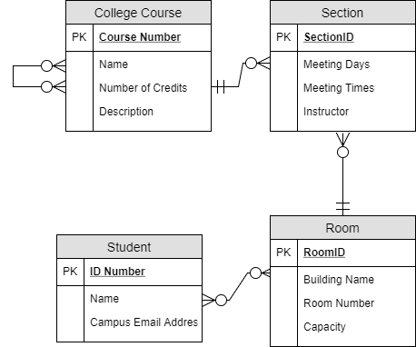

### Part 1, Case Study 2 – Project Management

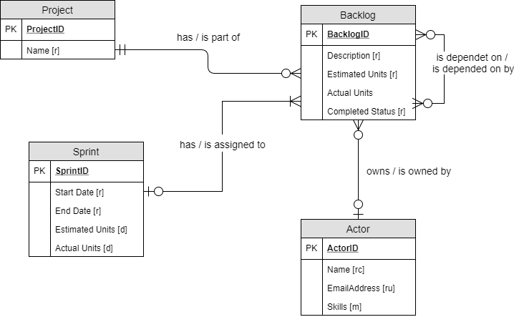

### Part 1, Case Study 3 – Book Publishing Database

|  |  |
| --- | --- |
| **Entity** | **Attribute** |
| Publisher | Name [ru]  Address [r]  Telephone Number [r] |
| Book | ISBN [ru]  Title [r]  Price [r]  Pages [r] |
| Author | Author ID [ru]  Name [r]  Address [r] |
| AuthorRoyalty | AuthorRoyalty ID [ru]  Author Name [r]  Book ISBN [r]  Royalty Rate [r] |
| Check | Check Number [ru]  Date [r]  Amount [r]  Author ID [r]  Book ISBN [r] |
| Address | Address ID [ru]  Street Number [r]  Street Name [r]  City [r]  State [r]  Zipcode [r] |
| **Relationships** | |
| Each Publisher has 1 or more Books, Each Book is part of 1 and only 1 Publisher, Each Publisher has 1 and only 1 Address  Each Author has 1 or more Book, Each Author has 1 or more Publisher, Each Author has 1 and only 1 Address, Each Author has 1 or more AuthorRoyalty, Each Author has 1 or more Check | |

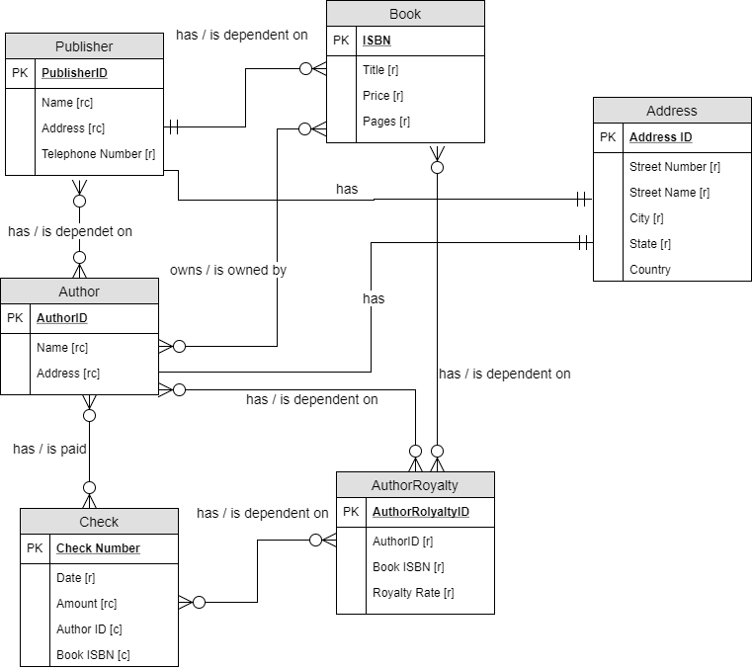

### Part 2, Part 1 – VidCast Conceptual Model

|  |  |
| --- | --- |
| **Entity** | **Attribute** |
| User | UserID [ru]  User Name [ru]  Email Address [ru]  Description  URL  Followers |
| UserTag | UserTagID  Tag  Description |
| Vidcast | VidCastID [ru]  Title [r]  StartDateTime  Duration  RecordCast  RecordingURL  ScheduleStatus [r] |
| VidcastRecording | VidcastRecording [ru]  RecordingURL [r] |
| ScheduleStatus_ref | ScheduleStatusID [ru]  Status [r] |
| **Relationships** | |
| Each Vidcast has 1 and only 1 User, Each User has zero to many Vidcast  Each Vidcast has zero to many UserTag, Each UserTag has zero to many Vidcast  Each User has zero to many User (Followers), Each User has zero to many UserTag, Each UserTag can have zero to many User  Each Vidcast has zero to 1 VidcastRecording, Each VidcastRecording has zero to 1 Vidcast  Each Vidcast has 1 and only 1 ScheduleStatus_ref, Each ScheduleStatus_ref has 1 to many Vidcast | |

